|  |  |  |
| --- | --- | --- |
|  | Rochester Institute of Technology  Golisano College of Computing and Information Sciences  Department of Interactive Games and Media  2145 Golisano Hall – (585) 475-7680 |  |

**Data Structures & Algorithms for Games & Simulation II**

**IGME 309-01, 2015 Spring**

**Final – Practical**

Instructions:

A) Read this whole document before you start.

B) Using the provided code, implement a program that replicates the behavior described below and in the provided sample (Ex02_Ds_DEMO.exe under _Binary)

You are handed out code that will draw this out of the box:

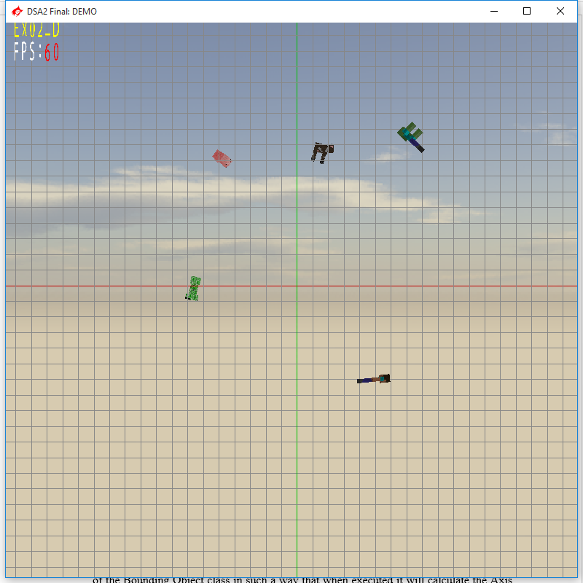

5 characters are drawn in the screen at a random position and a random orientation. Each object is then assigned a BoundingObject though the MyBoundingObject manager, this in turn will initialize the m_pOctreeHead variable that will display a box around all objects.

None of the calculations for the size and positions of the BoundingObjects Axis Oriented Bounding Box or Axis Realigned Bounding Box are correct, your goal is to fix them. At the same time the Octant needs the information of the Axis ReAlligned Bounding Box in order to calculate the right size to display.

All of the display functions are correct, you will just need to calculate the boxes and prepare the necessary variables for the display methods to use.

Your goal is to eliminate the Gimbal Lock by any means and have the object rotate the right way (again there is an example under the _Binary folder).

For the first part of your final you are expected to complete the Constructor of the BoundingObject class, it will take the list of vertices from the model and generate an Oriented Box out of them.

For the second part of your final you are expected to modify the SetModelMatrix method of the Bounding Object class in such a way that when executed it will calculate the Axis ReAligned Bounding Box.

For the third and final part of your final you are expected to modify the Init method of the MyOctant class to take all BOs from the Bounding object manager and generate a cube that surrounds all objects in the scene

Requirements:

* Your code MUST compile AND execute. I will not take points out of the program if it doesn’t compile AND/OR run, I will simply not grade it. If your program does not run it will receive a 0/100. If you are having trouble with something in the code comment out the lines, say what you wanted to do and what you suspect the issue is. That will result in partial credit, which is better than not having a grade.
* Memory Leaks are acceptable, points will be taken off, but the code will be reviewed.
* You only need to modify the following methods:

MyBOClass::MyBOClass(std::vector<vector3> a_lVectorList); //Oriented Box

void MyBOClass::SetModelMatrix(matrix4 a_m4ToWorld); // Axis Realigend B Box

void MyOctant::Init(void); //Octant initializer

* You get rid of the “trash files” (intermediary files).
* Zip your project (just your project not the whole solution, it should be less than 200kb) and upload it to the dropbox in my courses.

Grading:

(-???) Cheating:

Talking with anyone in person or online. You are only allowed to use MyCourses to download this file or upload your solution. Anything else is considered cheating.

(-100) Code not compiling or executing.

(-10 to -20) Memory leaks (You are not reserving new memory for this test so this shouldn’t be an issue)

(-10) For each uncommented method; I need to know what you are doing or trying to do.

(-10) You forgot to delete the _Delete folder

(-10) You forgot to delete the .sdf file

(33) Generating the Oriented Bounding Box

(33) Generating the Axis ReAligned Bounding Box

(33) Generating the Box on the Octree

Extra points:

For the extra points you are allowed to modify anything in the program but you need two submissions one for the regular part and one that is clearly labeled extras:

Surprise me (in a good way). As I don’t know how surprised I will be I can’t tell you how many extra points I will give you, just do your best, and as usual, in order to get the extra points you need to have a satisfactory degree in the required part.